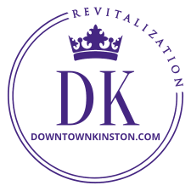
NEWS FROM DOWNTOWN KINSTON REVITALIZATION 04/2022
BBQ Festival on the Neuse Our largest annual event takes place downtown Friday and Saturday May 6 & 7, kicking off Friday evening with fast rising country music star Niko Moon at 8:30 on stage near the Farmers Market on Herritage Street.

This event usually attracts around 40,000 people to downtown. Be sure to take advantage of the potential business and show our guests our great Kinston hospitality. Attendees, be sure to walk around that evening and chat with all the cooks; a great bunch of folks who spend the night out tending their pits and pigs. Events like this are opportunities to do some business and get new customers. Have you never volunteered to help at BBQ Fest? You should. It is a blast! Contact Waylon Adams at wadams@also.com about volunteering, sponsoring or being a cook team, or being a vendor.

Our City has invested in 30 proper events barricades. All 30 will be used for the BBQ Fest and offer great advertising opportunities for you while supporting the host organization. Get your name out there in front of all the guests by sponsoring this popular event. Let us know and we will get you taken care of.
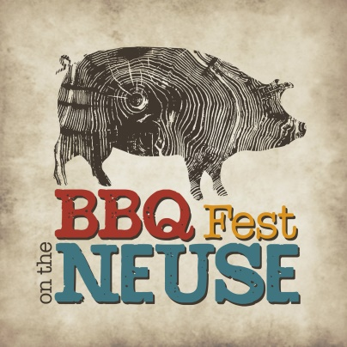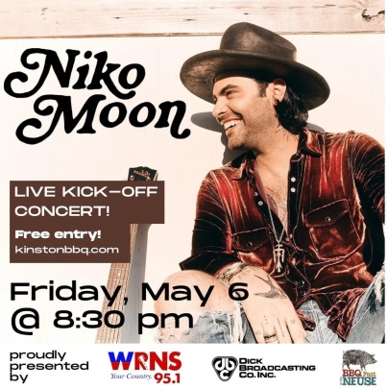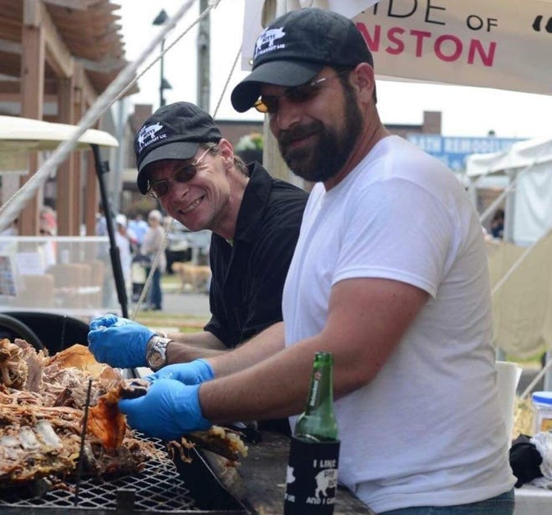
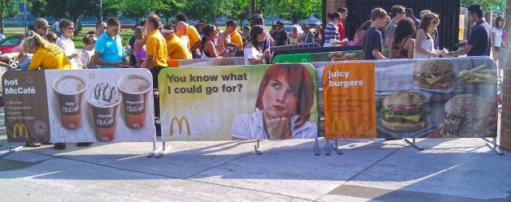
Your business here

North Street Pedestrian Mall Explored last year, the idea of closing North Street between Queen and Herritage Streets as a Summer Saturdays Pedestrian Mall similar to those in other cities like New Bern for entertainment, vendors, alfresco dining and imbibing in order to stimulate more activity downtown received enthusiastic support from downtown merchants who see this as a downtown business promotional opportunity. We hope this is the year to get this started.

Summerfest Downtown Kinston Revitalization’s annual Kinston Summerfest live music series is still in the planning stages. It will be scaled back this year to only 2 to 3 concerts rather than the usual 6 due to budget constraints. The first is currently slated for Saturday June 11, another on Saturday August 13, and the third music event is still being looked at.

DK Fundraising We cannot do what we do without you. No one likes asking for money or fundraising, but unfortunately for non-profits it is necessary. As our downtown projects continue to grow and expand, and as costs continue to rise, our budgets must keep pace. With the generous support of the community we have raised over $150K since 2018 to support projects and events for downtown, all from $1 to $10 to $100’s or more of dollars in individual and corporate contributions. Every dollar is appreciated and invested in each endeavor whether flower pots, plants and maintenance, or Christmas, Summerfest, street pole banners, etc. We are a 501c3 non-profit and your support is necessary to keep the train of transformation moving.

DK Face Book Please follow us on our social media page for the latest about downtown.

We Want You at Our Table If you are as passionate about transforming downtown as we are, we invite you to come aboard and get involved with us. Although our focus is the designated 28 square blocks of downtown, what we do downtown affects Lenoir County. Come be a change maker with us.

We Heard You We agree. There is a need for more lighting downtown and we hope to have some in place similar to the photo below for the BBQ Festival and the North Street Pedestrian Mall to create a more festive atmosphere while adding more illumination.
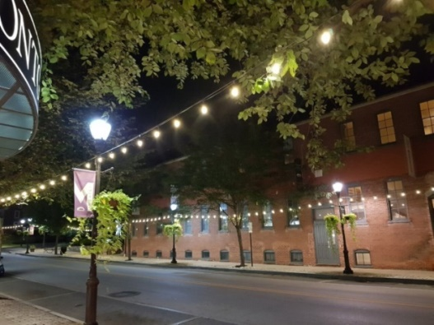

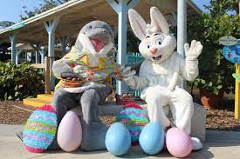
Easter If your downtown Kinston business is doing something special for Easter, let us know so we can help you promote it. When you post it, tag Downtown Kinston Revitalization. Also, tag We Report Neuse News.com, Word of Mouth Kinston, Lenoir Community Discussion, and other groups you may belong to. Make your social media work for you.

Leon Steele, Director of Downtown Revitalization, lsteele17@suddenlinkmail.com, 252-522-8003
Follow Pride of Kinston/Downtown Kinston Revitalization on FB for lots of updates
Visit our website at www.downtownkinston.com

