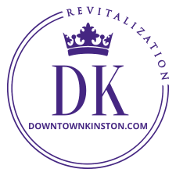
NEWS FROM DOWNTOWN KINSTON REVITALIZATION
June

2022
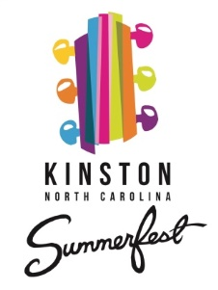
Kinston Summerfest kicks off on Saturday June 11th with family fun in Pearson Park downtown at 3:00 PM, followed by live music from 7:00-10:00 PM performed by Breadwine & Blooze playing all of your favorites from old school to beach to boogie. You may remember this awesome band and their spectacular performance during last year’s July 4th weekend fireworks display.

Shop in the park with vendors, feed your crew from the food trucks, and wet your whistle with Pepsi products, and beer and spirits selections from our local watering holes and producers.

On July 9th, enjoy a local group, Soul Movement, and on August 13th you can shake it like it’s hot to one of the State’s most popular party bands, Main Event. Bring your lawn chairs and sunscreen. No coolers, please.

We want to acknowledge our Summerfest sponsors to date for their generosity in helping make our music series the big event it has become; thank you BBQ Festival on the Neuse, Minges Pepsi, and our Parks and Recreation folks, as well as our volunteers who help deliver the event to you.

Free events are not free. Bands must be paid, marketing must be done, banners must be printed and insurance must be purchased. Your annual Summerfest series can cost upwards of $25,000 to host. Please consider being a sponsor of this great event.

BBQ Festival on the Neuse last month was arguably the best yet and drew a record crowd to our downtown with many from other states. Events always need volunteers to assist. These are great opportunities to experience behind-the-scenes while showing support and love of community. Many hands do make light work.

Kinston’s first Renaissance Faire On the weekend following BBQ Fest a new, hugely successful event took place at our Fairgrounds. Although not a downtown event, close to 3,000 (mostly costumed) people descended on Kinston for 2 days of activities at the Renaissance Faire. Thank you to Rob Gauthier, Alison Merritt, and a huge team of volunteers for putting this on.

Attention businesses and creative types who love Christmas lights. Participate in our annual Tinsel Trail in Pearson Park. Lease a space from DK to install any type of lighted holiday display you like (except inflatables) to showcase your business or creative endeavors and express your gratitude to those who support your business. Over 5,000 people visited the Pearson Park lights in December 2020. Prizes will be awarded to the top three based on public voting the night we turn on the lights; November 19th. Follow Downtown Kinston Revitalization on Face Book for notifications of when online registration opens in the fall and reserve your spot right away. Spaces are limited, so do not procrastinate. Start planning your installation today for a 10x10 space.

Downtown merchants, please start making your plans for parade day, Saturday December 3rd. The parade is in the evening, so you have all day to make your registers ring. DK wants to help you get the word out to promote your special activities that day. Help make parade day a full day for the family to spend downtown. And don’t forget your personal billboards; your Christmas window displays. Let’s light up the town.

Merchants & Board Meetings are important to attend. If you are a downtown property owner or business in the MSD, we want you at our table. Learn who we are, how we operate, what we do for you, and how you can be involved. Watch for announcements. Get involved with the organization spearheading the transformation of your downtown. Board meetings are open to the public and are typically held after work at 5:30 PM on the last Thursday of the month at the library on Queen St. Please come. We are also accepting applications for those who want to be actively engaged members.

Flowers DK continues to invest in pots, dirt, fertilizer, and flowers to keep downtown looking nice. We pay someone to water them and volunteers organized through our design committee plant them. If you have flowers, please help us keep them thriving. It would be much appreciated by everyone.

Have Downtown Pride Trash is an ongoing issue downtown. Our City and streets belong to all of us. If we collectively do our part to help keep it tidy it will be beneficial to and appreciated by all concerned.

Construction downtown is investment in downtown Currently we have several projects in the works. Lea Henry of Rocky Mount purchased 317-323 N Queen Street that housed the Jewel Box and Johnson Music businesses. UNC Greensboro Department of Interior Architecture in partnership with our State Main Street office is preparing renderings for the mixed-use build-out that will bring much needed commercial and residential activity to Queen Street. Our downtown architecture firm of Dunn and Dalton is also involved. Work should begin in a few months.

California developer, Dave Machado, is tackling his next Kinston project on E North Street. The former Shoe Hospital is being converted to 4 market rate apartments. His other project was the burned out law offices on E Gordon across from the Mintz Law firm. These have 4 market rate apartments, as well.

Streamline Developers, a local company, is in the process of converting the former Christopher’s Café at N Queen and E North to an office with 3 apartments.

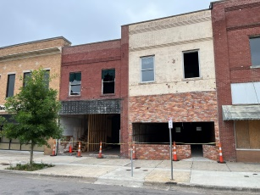
Graham King, owner of Commercial Flooring at 415 N Queen, is working on 2 buildings adjacent to his flooring company to provide 2 additional commercial spaces for lease and one apartment above each. King has applied for a DK façade grant and we are applying to UNC Greensboro Department of Interior Architecture for renderings assistance.

And then there is the major and impressive renovation underway of Lovick’s Café on Herritage St.
Photo: Neuse News
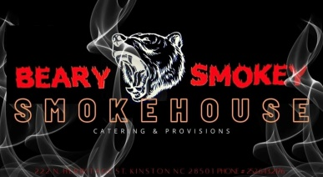
There is also another new eatery opening in the former Upstairs at the Market at Mitchell and North Streets. Beary Smokey Smokehouse Catering and Provisions promises to be another great addition to what is shaping up as a popular downtown Kinston entertainment and shopping district.

Rumor has it that more exciting things are coming online, too. Stay tuned for announcements.

It is not exactly commercial construction, but it is needed, and that is the new restrooms at Pearson Park. Thank you to our generous community partners at Woodmen Life Chapter 46.

For Sale Hawks Nest Café at Queen and E Caswell is for sale. The established restaurant that is on the National Register of Historic Places needs a new owner. Upstairs would make 2-4 great apartments. Contact Realtor Nathan Perry at (252) 686-5317. The more people we have living downtown and the more businesses we have, the quicker the magic returns. How about an Italian Bistro or Seafood restaurant? Maybe a wine and cheese shop that also sells all the wine accessories and glasses?

Why all this activity in little old Kinston? Because believe it or not we have become one of the coolest small towns in ENC with the hippest vibe . . .great events, fun pubs, good food, axe throwing, Bird scooters, live music and event spaces, a variety of shopping opportunities, a cigar lounge, art galleries, great hotels, and terrific folks and a growing guest population.

Façade Grants for DK’s new fiscal year are about to become available. Are you embarking on a downtown Kinston rehab project? We have some façade grant funding that may help you out. Contact us for details and application.

Follow the journey. Follow Downtown Kinston Revitalization on Face Book and Instagram.

Keep the vibe alive, y’all, and take pride in your community.

Leon Steele, Director of Downtown Revitalization, lsteele17@suddenlinkmail.com, 252-522-8003
Follow Pride of Kinston/Downtown Kinston Revitalization on FB for lots of updates
Visit our website at www.downtownkinston.com

