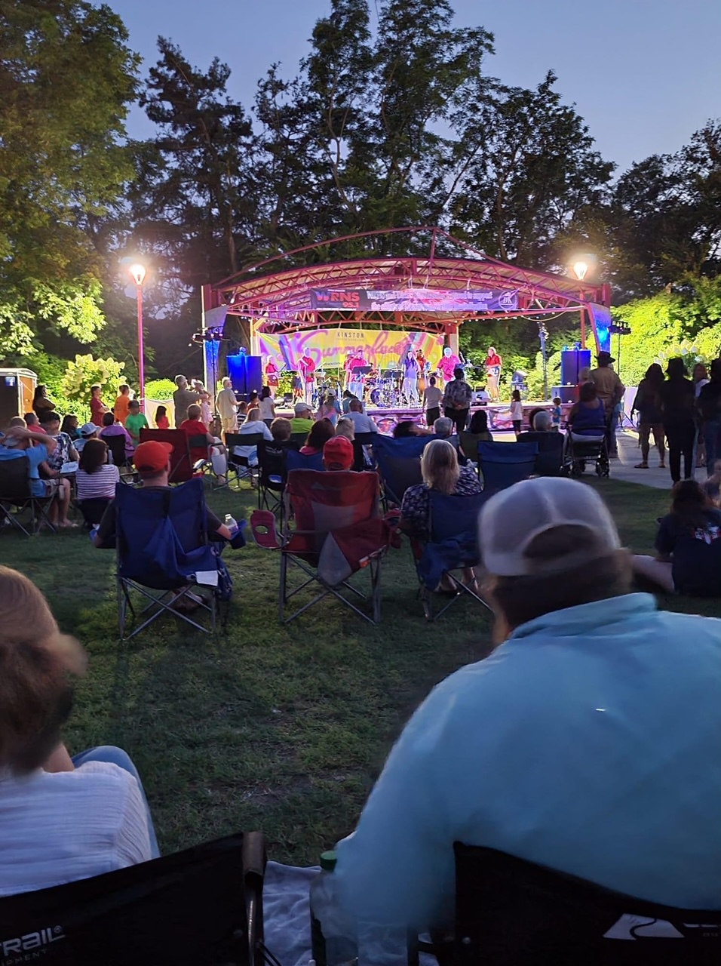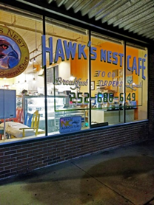

**KINSTON SUMERFEST**

**Who does not love live music!**

**NORTH TOWER BAND, ALL YOUR FAVORITES**

**Saturday July 9**

**MAIN EVENT BAND, END OF SUMMER PARTY**

Perhaps you have heard their new hit release,

*Poor Side of Town*.

Beer, soda and water will be available among other things including food trucks. This is a free music event. All are welcome to attend. Interested vendors may register and pay online at www.downtownkinston.com.

**LET’S PACK THE PARK**

Your non-profit host needs your help in paying for your Summerfest series . Please consider being a financial supporter of this great, annual community event. Also, volunteer to assist with the events and learn how it is done. It is fun behind the scenes.

FOR SALE

Revitalizing the Heart of Lenoir County

**JULY 2022**

Hawks Nest Café at Queen and E Caswell is for sale. This established restaurant in a National Register building needs a new owner. Upstairs would make 2+ great apartments. Contact Realtor Nathan Perry at (252) 686-5317. The more people living downtown and the more businesses we have, the quicker the magic returns.

Restaurant equipment is being sold. Contact Judy Anderson Johnson on FB for info.

Think of the possibilities!

**LIVE MUSIC IN PEARSON PARK, 7:00 TO 10:00 PM**

**FAMILY FUN 3:00 TO 6:00 PM**

**SHOW YOUR LOVE OF LIVE MUSIC**

**MAKE A DONATION TO DK**

**AT THE SHOW**

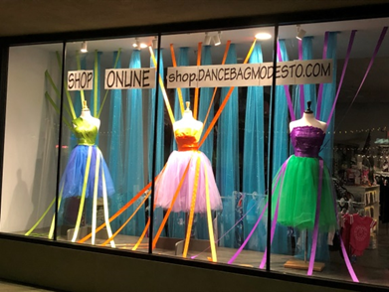

**Show Off!** Your display windows are your personal, free billboards. Creative displays that remain lit at night attract evening guests who are enjoying downtown. Give them an excuse to window shop and come back to see you. Let them know how to contact you to make a purchase by phone. Also, leaving the lights on at night helps add light to the street.

Your windows are also message boards. Do you have an online store? Do you host FB LIVE shopping events? Are you on social media? What is your web address and telephone number? Window decals or other signage helps you communicate with existing and potential customers.

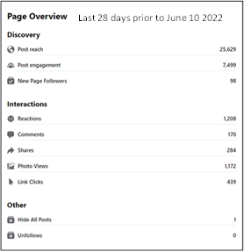

**GROW YOUR CUSTOMER BASE** Try boosting your social media posts to areas beyond your personal followers in order to capture new customers. Below is a good illustration of the results of boosting a Kinston Summerfest post regionally.

DK’s regular reach is about 4,000. Notice the numbers below associated with a $100 FB boost to surrounding regions that are actually drive-market areas for Kinston. If this is not enough to sway you to cough up $100, remember during the Christmas Parade how the downtown streets were lined with thousands of people for the entire parade route? How’d that happen? Marketing; a combo of regular social media posts combined with multi-county LED billboards, all ramped up the closer to event day and bolstered with boosts blasted to our neighbors.

People don’t know if you don’t tell them.

Anyone can post just to be posting, but DK markets experiencing downtown while you market your services, product, and lifestyle. It all boils down to consistency in branding, reach, audience, and constant messaging. Take a page from the book of the big boys’ and use it for yourself. That little computer we hold in our hands 24/7/365 is an incredibly valuable marketing tool. Put it to work for you in a meaningful way.

[WWW.DOWNTOWNKINSTON.COM](http://WWW.DOWNTOWNKINSTON.COM) 252 522 8003

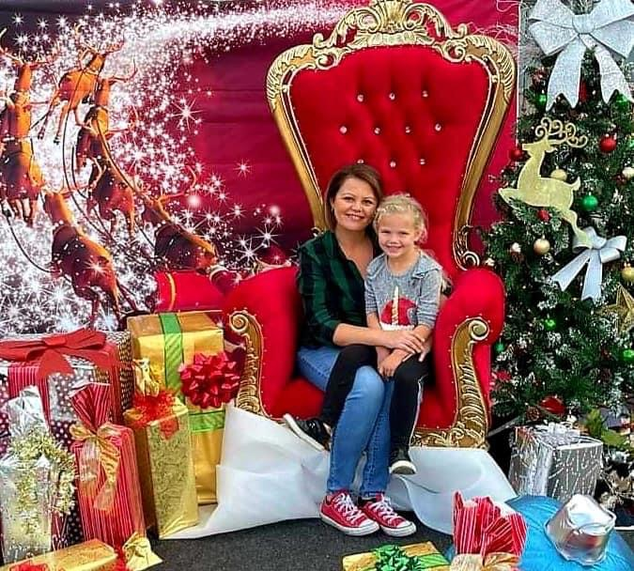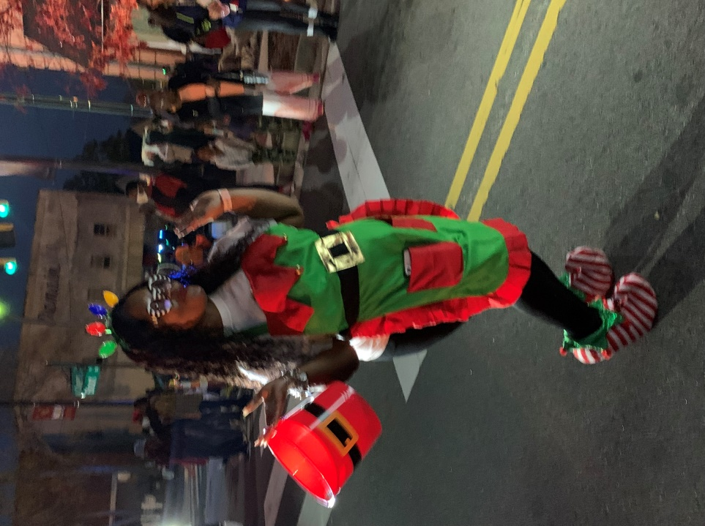

**Merchant & DK Board Meetings** are important and open to the public. If you are a downtown property owner or business in the MSD, we want you at our table. Learn who we are, how we operate, what we do for you, and how you can be involved. Watch for announcements. Get involved with the organization spearheading the transformation of your downtown. Board meetings are typically held after work at 5:30 PM on the last Thursday of the month at the library on Queen St. Please come. Or, join a committee, be a sponsor, or help support one of the many things we do for downtown that may be of particular interest to you.

**Kinston 101 Citizen Academy** Since February 2020, the City of Kinston offers an amazing 10 week, one evening per week program for 20 citizens during the Spring and Fall. Citizens learn how each Department works from the leader of that particular Department. Site visits are included. It is extremely beneficial to know how City finance works, how the Police Department functions, Inspections and Code Enforcement and others operate. Even Downtown Kinston Revitalization participates. The next program is scheduled for September 1 – November 3. Applications open June 21. Sign up at www.ci.kinston.nc.us/576/Kinston-101 or phone Sylveonna Holmes-Washington at 252-939-3271. You will be glad you did. Space is limited to 20.

**Downtown Merchants** Christmas Parade day is Saturday December 3rd. The evening parade enables you to make your registers ring all day. Let Dk help you get the word out to promote your special activities that day. Help make parade day a full day for the family to spend downtown with you. What are you planning? Let us know.

**THANK YOU**

**COMMUNITY BENEVOLENCE CONTINUES**

You will recall that Woodmen Life Chapter 46 is responsible for the generous donation of funds for the much needed restroom at Pearson Park.

Please join us in thanking the Ram Neuse Lions Club for another Pearson Park enhancement with their purchase through DK of a beautiful new bench for the park. It will be arriving soon.

This is the kind of community benevolence that benefits everyone.

**FOR SALE DOWNTOWN**

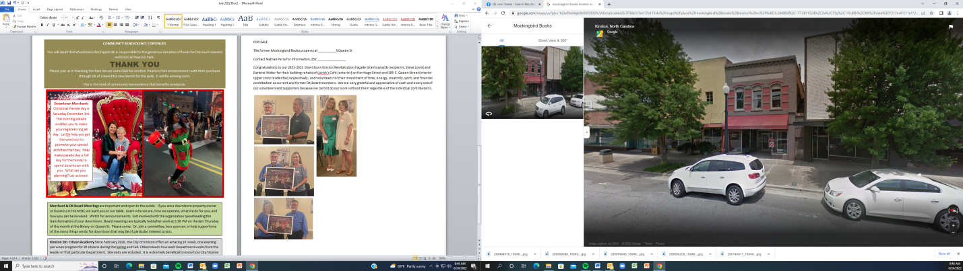The former Mockingbird Books property at 113 N Queen St is on the market.

Listed at only $29,000 this 3,003sf building is gutted and ready for your downtown dream-build behind its beautiful façade. Downtown Kinston Revitalization has matching façade grant funds that may assist with portions of your rehab project. Contact Nathan Perry Realty at [nathan@nathanperryrealty.com](mailto:nathan@nathanperryrealty.com) or 252 686-5317 for information on purchasing this building.

Congratulations to our 2021-2022 Downtown Kinston Revitalization Façade Grants awards recipients, Steve Lovick for their building rehabs of Lovick’s Café (exterior) on Herritage Street and Darlene Waller’s 109 S. Queen Street (interior, upper story residential) and volunteers Tonya Adams, Lisa Ayres, and Omar Grady for their investment of time, energy, creativity, and spirit, as current and former DK Board members.

We wish we could have recognized every single one of our supporters and worker bee volunteers as we are so grateful and appreciative of each and every one regardless of their degree of involvement because we cannot do our work without them.

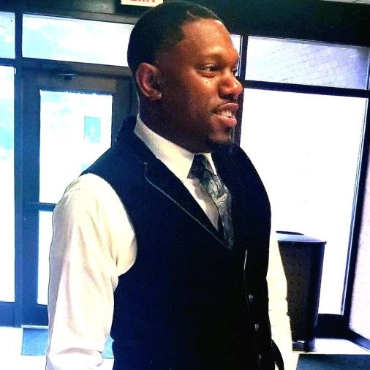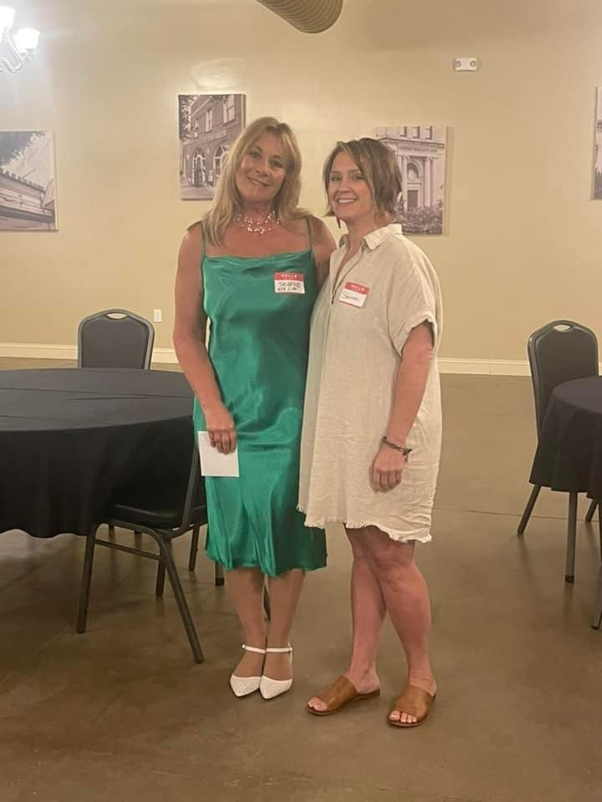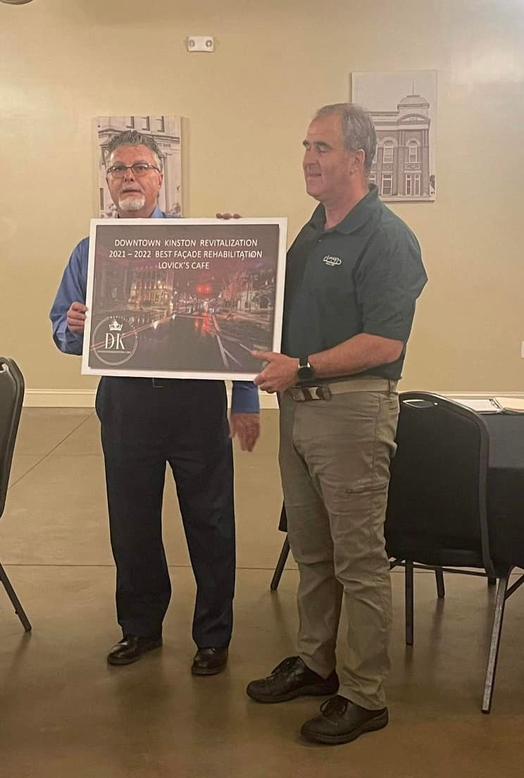

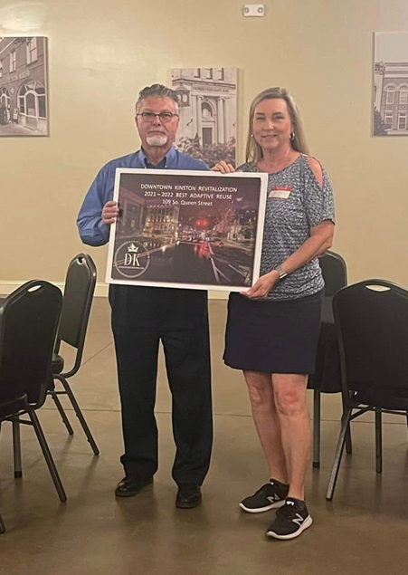

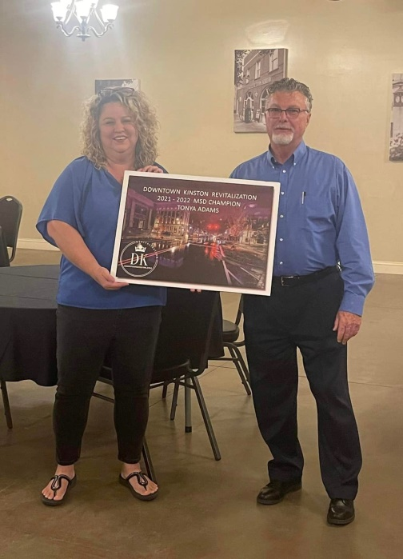

**July DK Board Meeting**

**Thursday July 28**

**Library Auditorium, Queen Street**

**5:30 PM**

**Open to the public**

**Have something to share? Get on the agenda: leonsteele17@suddenlinkmail.com**

*Don’t just pose a problem. Be part of the solution.*