HAPPY 2022 FROM DOWNTOWN KINSTON REVITALIZATION
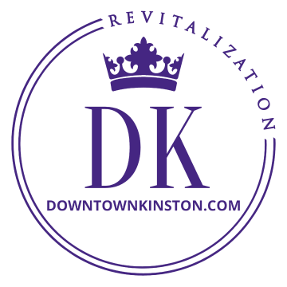
Invitation Are you aware that Pride of Kinston had a rebranding in 2021? It is now Downtown Kinston Revitalization (DK).
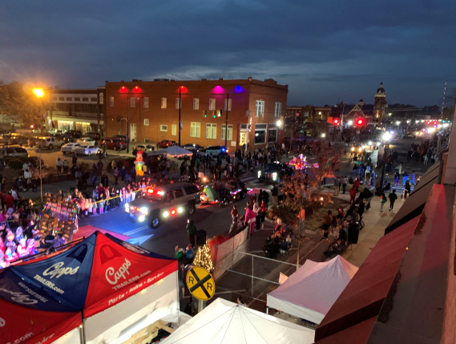
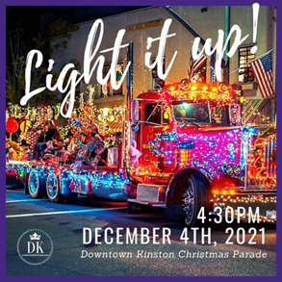
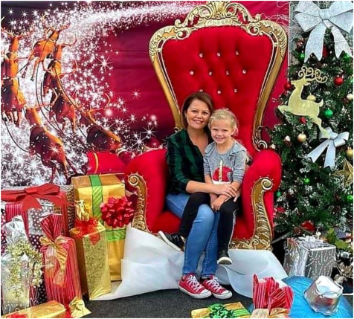
Big Time Parade Your Kinston Christmas Parade has made it to the evening again after many years. This has many advantages for all of us. Besides being enormously more magical, merchants now have the opportunity to plan daytime holiday shopping events that DK will help promote in order to entice and keep families downtown all day. Christmas is now a big deal for Kinston what with hosting one of the top parades in the region, the over the top Pearson Park lighting ceremony and the business Tinsel Trail experience. In 2021 the parade had 75 actual entries with a total of 99 in the line-up and 300 actual participants, began at 4:30 PM, lasted 2.5 hours, and featured a little bit to a lot of everything. The Kinston Parade attracts a massive number of people to downtown because it is spectacular and is promoted very well for that reason. When combined with the Pearson Park experience, Christmas in Kinston rivals the BBQ Festival.

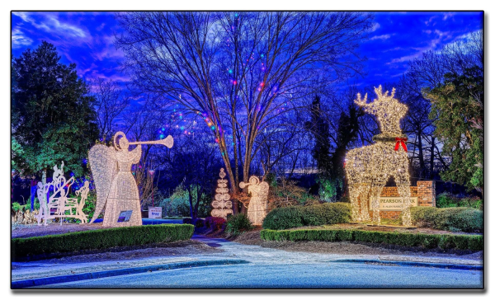
Promotions Since DK inherited the parade in 2018, it has been broadcast live to over 20 states each year by Neuse News, hosted by BJ Murphy and Martha Bishop. That is very valuable marketing for Kinston and Lenoir County as it promotes a positive message and reinforces our community pride and creativity in setting a standard for Lenoir County. Parade attendees have the opportunity to experience all we have to offer downtown and enjoy a positive experience in Kinston at the same time. DK parade sponsors get great exposure during this broadcast, too. A $500 business sponsorship for Christmas includes a $100 spot on the Tinsel Trail in Pearson Park that provides an entire month of promotion for your business at which you can display your own Christmas spirit. It also comes with 4 seats on the Parade’s red carpet. DK is a 501c3 so your support is tax deductible. Tinsel Trail, by the way, saw over 5,000 visitors in December 2020.
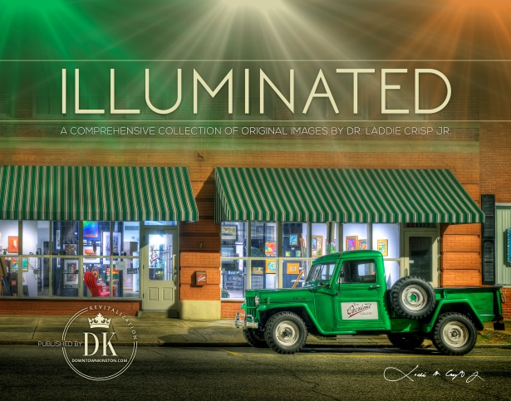
Kinston in Pictures DK was gifted the use of Laddie Crisp’s magnificent photos of Kinston to create a coffee table book for the benefit of DK for which Brandon Potter did a beautiful job laying out. A one-time run of 500 copies were printed with more than half pre-selling before they went to print. They make great additions to your personal Kinston library collections as well as gifts. Get yours while they remain available from our office or website (www.downtownkinston.com), or Leon Thomas Treasures on W North St, downtown.

Two in ‘22 North and Mitchell Street is expected to see a makeover that creates a better connection to our community front yard; Pearson Park and the Dragon Playground. Plans include a Shirley Herring Memorial Garden with architectural features on the SE Corner facing the playground, the building at that location will be painted, a sensory path for children will be installed on the sidewalk in front of the building, the intersection will be painted and a fun crosswalk added, as well as traffic-calming devices, i.e., additional stop signs or speed pads/bumps to make the intersection safer.
We also hope to kick-off the North Street Summer Saturday Pedestrian Mall. The plan is to close W North St at Queen and at Herritage to allow for more outdoor dining, live music, maybe vendors or whatever the merchants arrange and schedule to feature for the summer that will provide another excuse to enjoy downtown on Saturdays. If successful, consideration will be given to expanding it to Mitchell St. with Herritage, of course, remaining open as a major thoroughfare. The inconvenience of a perceived lack of parking in that block of W North on Saturday should not be an issue as there are plenty of free parking lots mere feet to yards away.
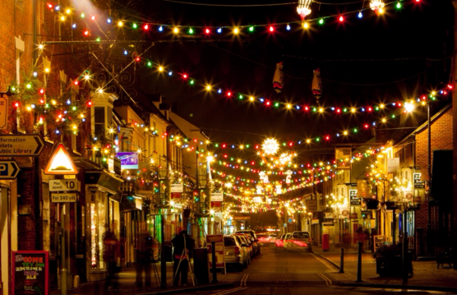
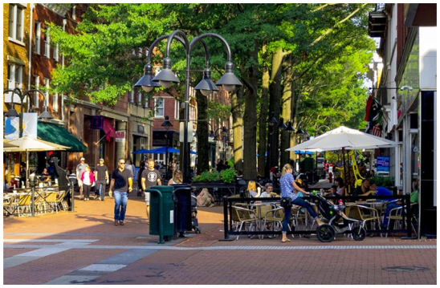

The DK Board meets the last Thursday of the month at 5:30 PM at the library. You are welcome to attend the meetings as a guest as well as join one of the committees to help with
the transformation of downtown.

Leon Steele, Director of Downtown Revitalization, lsteele17@suddenlinkmail.com, 252-522-8003
Follow Pride of Kinston/Downtown Kinston Revitalization on FB for lots of updates
And visit our website at www.downtownkinston.com

