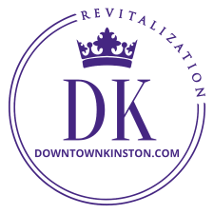
NEWS FROM DOWNTOWN KINSTON REVITALIZATION
May

2022
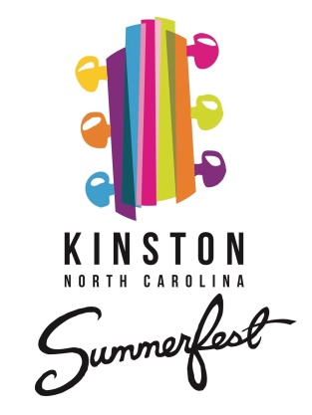
Kinston Summerfest This year there will be 3 concerts in Pearson Park. On June 11th, Breadwine & Blooze returns to kick off the summer. You should remember them from last year’s spectacular performance during the fireworks display. On July 9th, a local group called Soul Movement performs, and on August 13th you can enjoy the popular regional band Main Event. Bands play from 7:00 to 10:00 PM in Pearson Park.

Meanwhile, We Are Getting Ready for Christmas I know! We have not even gotten our first summer sun-burn yet and we are already talking about Christmas. I get it, but our work here is akin to the magazine publishing business in that we have to plan months in advance; working in the future while also working in the present.

Kinston & Lenoir County is the place to be for Christmas in ENC. We have wonderful small town parades in Pink Hill, LaGrange, and Deep Run and a parade in Kinston that rivals big cities. A family can enjoy a broad range of holiday festivities throughout Lenoir County. Let’s OWN Christmas in ENC!
Besides great parades, we have other amazing holiday events. Some you must see in Kinston include the magical bell ringing concert at Gordon Street Christian Church, as well as the extremely popular and spectacular orchestral and choir service at Queen Street Methodist Church, to name only two. We hope that other professional quality events we enjoyed pre-COVID will return this year such as The Messiah at First Presbyterian and St. Mary’s Episcopal Boars Head and Yule Log Lighting.

Here are some dates to go ahead and mark on your calendars.
- Saturday November 19, Official lighting of Pearson Park, Tinsel Trail, Neuseway Nature Center, King Street Bridge, and downtown
- Saturday December 3, A Kinston Christmas Light the Night Parade, 4:30 PM

Lighting the park earlier in 2022 gives everyone a longer period of enjoyment as well as 2 extra weeks of exposure for those participating in Tinsel Trail.

What is Tinsel Trail? Traditionally, it is a collection of Christmas trees sponsored and decorated by various businesses, organizations, or individuals, sometimes as a fundraiser.

Tinsel Trail in Pearson Park is a bit different. We encourage participants to place any lighted Christmas installation they like (other than inflatables) with your sign in roughly a 10’x10’ space in Pearson Park leased through our organization as part of the park lighting experience. It promotes your business or organization, or creativity while also thanking your patrons and shows community support for the Christmas lighting endeavor. Over 5,000 people visited the park lights in December 2020. That is a great deal of exposure for a few tax deductible bucks.

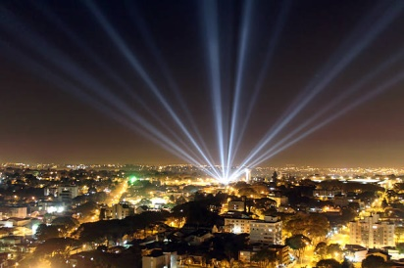
Special Request Because your Kinston Christmas Parade is so great and we now have expectations to maintain that way, we need to bump it up just a bit each year.

Can some of you please help us out with some of these needs?
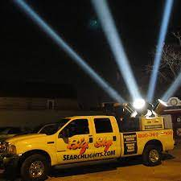
- We need something really cool for Santa to ride in since we do not have a proper Santa float
  - It must be motorized since horses do not like to walk on the carpet and they are prohibited from the parade for various reasons, unfortunately.
- We need a sponsor for the foam cannon
  - This is a blast, literally! Both big and little kids love it, but probably the most fun is blasting the crowd with foam.
- We need all local and area schools participating in the parade
- Klieg Lights will let EVERYONE in Lenoir County know there is a parade going on and would not only add to the light show, but deliver a great deal of high visibility drama
- Be a parade sponsor. This year we have 30 particular opportunities for business sponsorship promotions on our new barricades.
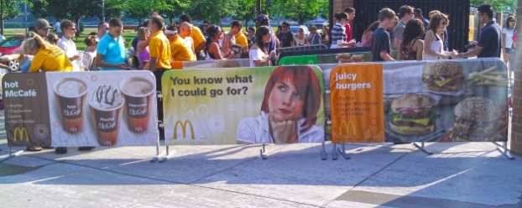
Have you seen the Lazy Boy recliners on Hoveround scooters? It would be a hoot and a hit to have a slew of Snuesers in the parade, especially if they all dressed as Christmas characters. What do you say, men? Do you have what it takes?
www.youtube.com/watch?tv=6S2TCspEUlI

Your business here

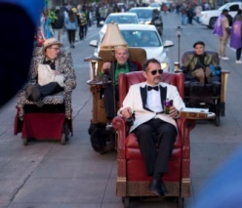
Merchants: This is very important Please start thinking about your plans for parade day to drive business to you so we can help you promote it. Help make parade day a day for the family to spend the day downtown with you. The parade is in the evening, so you have all day to make the registers ring. Let us help you get the word out.

Leon Steele, Director of Downtown Revitalization, lsteele17@suddenlinkmail.com, 252-522-8003
Follow Pride of Kinston/Downtown Kinston Revitalization on FB for lots of updates
Visit our website at www.downtownkinston.com

