

Revitalizing the Heart of Lenoir County

**August 2022**



What we hear:

“Kinston has not looked this good since the 1970’s.”

“Kinston has not been this popular since the Sugarhill girls.”

“Kinston has not had a live vibe since the tobacco warehouse dance clubs.”

“Kinston has not seen this much out of town investment in decades.”

Yeah. We did that with the help of passionate volunteers and citizens who wanted to help make it happen and with extensive, broad-based, targeted marketing.

Thank you for your support.

Kinston is and has belonged to the National and State Main Street organizations since 1984; one of the very first communities accepted into the program.

The Main Street program began over 30 years ago when the National Trust for Historic Preservation recognized that small town historic commercial districts were dying as a result of neglect, disrepair, complacency, and other factors. Their study identified what they call the *Four Point Approach* to revitalization; Design, Organization, Promotion, and Economic Vitality. Utilizing this methodology in conjunction with other Main Street protocols has revived many communities across the U.S. It is a proven recipe for success if applied. Many millions of dollars have been reinvested in downtowns and too many jobs to count have been created or retained as a result. The trend to live downtown again has rippled throughout the country and continues to grow. Kinston achieved designated Main Street status from 2001-2002. However, as an Affiliate program we remain able to benefit from a network of communities and State and National staff for various forms of support and guidance.

Main Street and Downtown Kinston Revitalization is much more than planting flowers, painting a building, and planning events. It is not a club. It is a business that impacts the entire County. It involves a great deal of work and a great deal of community support. The results of downtown transformation ripple throughout the community. It is not a one-person or a small group effort. It is collaborative effort of many individuals and groups.

We are truly appreciative of the support of everyone who helps make it possible.

**Kinston:**

**It’s A New Dawn**

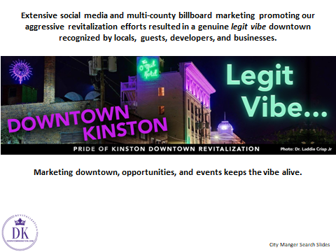

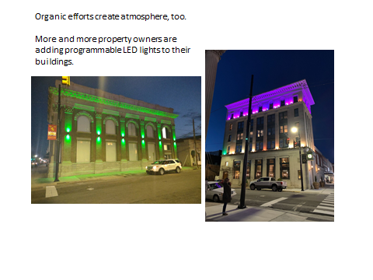

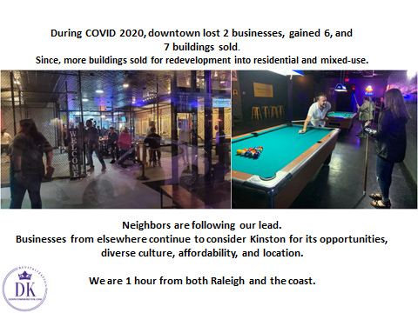

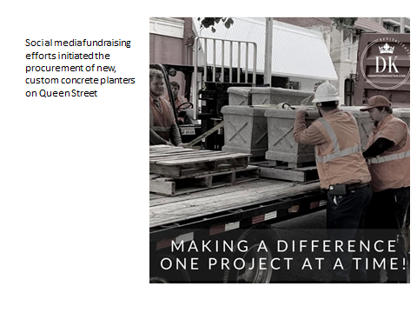

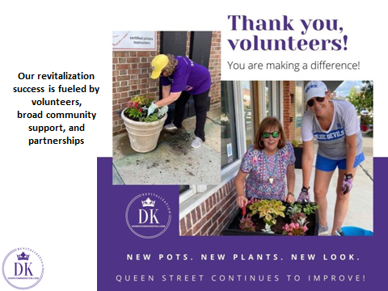

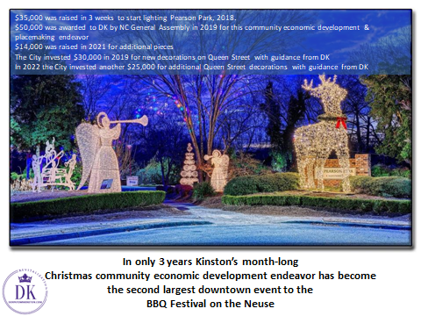

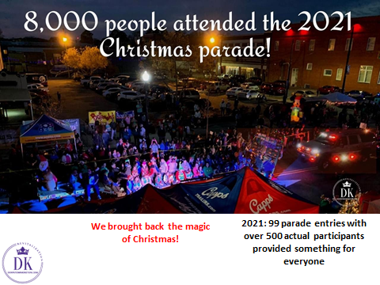

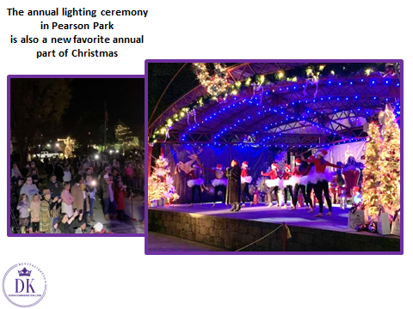

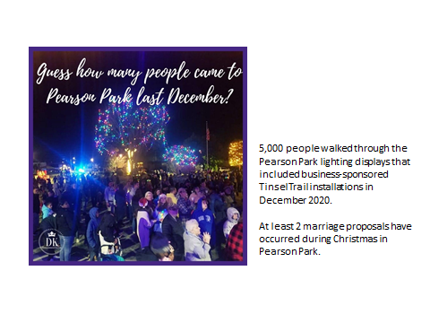

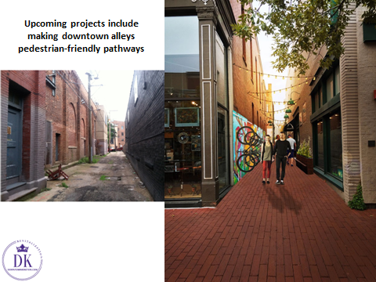

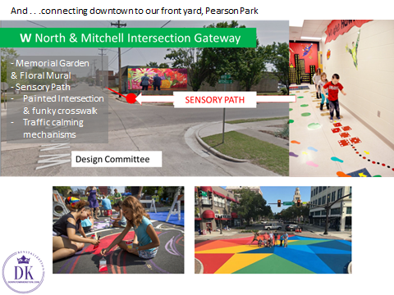

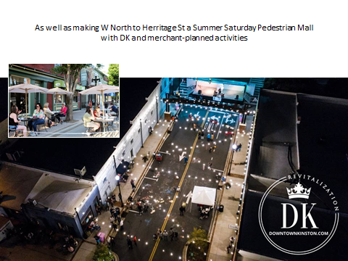

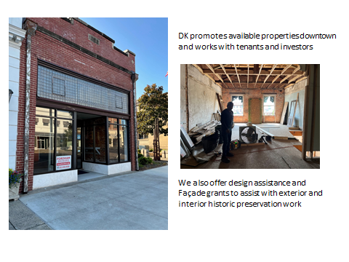

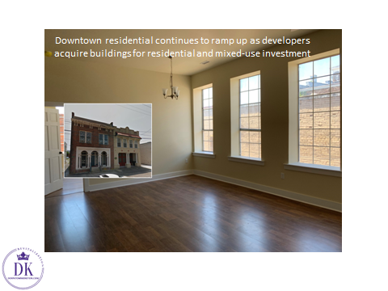

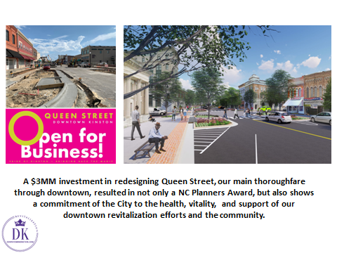

With the infrastructure improvements this project was a $10MM investment.

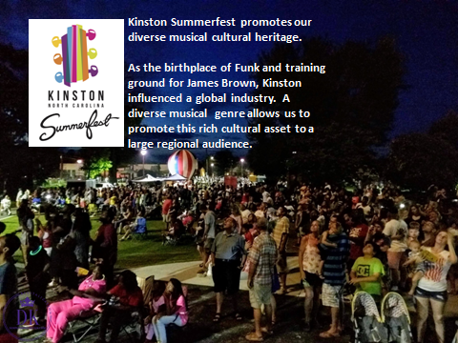

**Come out Saturday August 13th for our final 2022 Kinston Summerfest event with family fun 3-6PM and live music 7-10PM with the Main Event Band.**

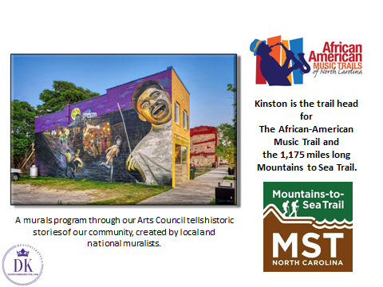

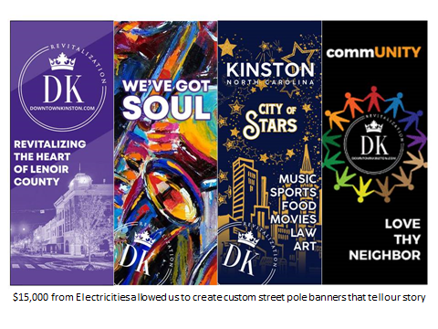

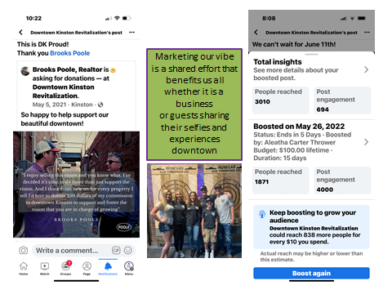

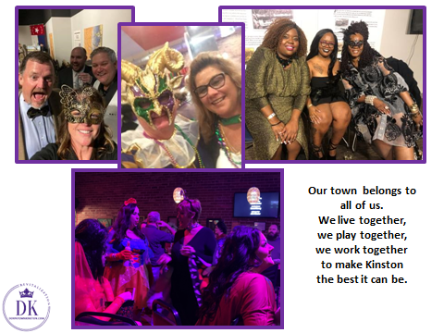

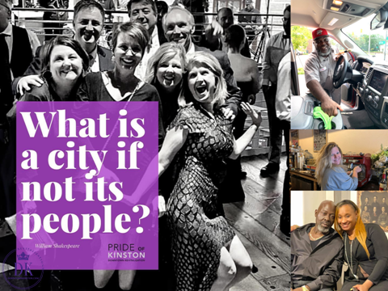

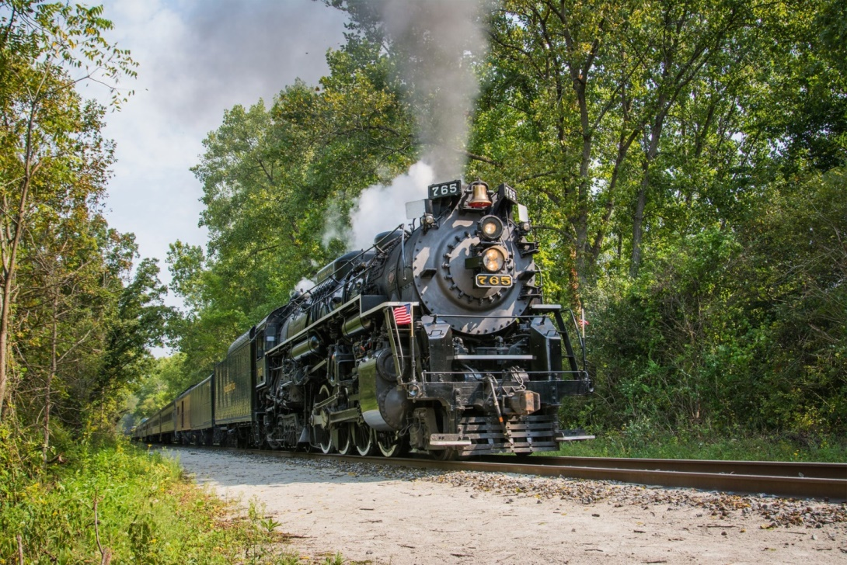

Get onboard. Let’s ride this train!